**TABLE OF CONTENTS**

Title of the project………………………………………………………2

Introduction & Objective of the Project………..................3-4

Tools /Environment Used……………………………………………5-6

Requirement and Analysis

* 1. Problem Definition….……………………………………...7
  2. Feasibility Study ………………………………………………8-9
  3. S/W model used…….……..…………………………………10
  4. Data Flow Diagram………..…………………………………11-14

Complete Structure

1. Modules and their description………………………………15
2. Data Integrity Constraint….……………………………………16
3. ER Diagram…..………………………………………………………20
4. Data structure………………………………………………………21-24

Project Screenshot ………………………….……………………….24-38

Project Code………………………………………………………………38-88

Testing………………………………………………………………………89-91

Implementation of Security ….………………………………….92

Conclusion ………………………………………………...................93

Bibliography.……………………………………………...................94

**ACKNOWLEDGEMENT**

This project bears the imprint of many persons and it gives me great pleasure to express my heartiest gratitude towards them.

I take this opportunity to express my deep sense of obligation to Mr. Faisal for giving me an opportunity to undergo this training.

I would like to show my sincere thanks to Mr. Faisal for his ample guidance. He encouraged me on each and every step.

Lastly, I would like to convey my reverential salutations to my friends and other member of the staff for their valuable suggestions and unending support.

Place: Lucknow

Date :

1. Title of the project

DeskSavvy

1. Introduction

In the fast changing world, information technology and information management are going to play an important role. We are living in the computer age during past some year .The computer has gaining popularity. Computer revolution found its way into almost every aspect of human life and living. A computer is admirably suited to handle any information and hence is an information processor that is, it can receive data, perform some basic operations on that data and produces results according to a predetermined program.

DeskSavvy is a well-planned system designed in order to provide well-structured mechanism to store record of all employees and their salary. It maintains complete record of employees, their salary data of past etc.

This proposed application will manage all the needs from both ends from employees end as well as from management end.

Advantages Of DeskSavvy

**Save Effort:**DeskSavvy System is easy to understand and simple to use. Its main advantage is no Prior payroll experience required.

**Save Money:** Save money by cutting down your expenses on additional

Man- power, paper, printing courier.

**Save Time:** Process monthly payroll and generates challans in seconds.

Save Environment: No Papers used,

1. Objectives

In the background DeskSavvy the entire manual and paper work which was done in the past,has to be removed by the use the web technology of the present scenario.The old conventional technique of recording data and processing would be removed and web enabled software would replace that. Management should be able to know the record of all employees past attendance. Their salary data can also be generated. If the management introduces some new salary structure, new courses, new designation etc these changes can also be done very easily.

1. H/W& S/W REQUIREMENT specification

Some software & hardware for running our software smoothly on a computer or laptop. Minimum Requirements are given below:

Hardware Requirements

* Pentium IV Processor
* 512 MB RAM
* 40 GB HDD
* Color Monitor
* Keyboard, Mouse

Software Requirements

**Front-end Tool:** - JSP, HTML, JAVASCRIPT.

* + - * + User friendly
        + Low Cost Solution
        + GUI feature
        + Better designing aspects.

**Back-end Tool:**- MySQL

**IDE:**- NetBeans, My-SQL

**Features are**:

* + - The graphical management tools make it extremely easy to manage the server.
    - Security
    - Portability
    - Performance
    - Scalability
    - Reliability

1. SYSTEM ANALYSIS
   1. IDENTIFICATION OF NEED

**Definitions of problems**

• **Not User Friendly:** The existing system is not user friendly because the retrieval of data is very slow and data is not maintained efficiently.

• **Difficulty in report generating:** We require more calculations to generate the final result so it is generated at the end of the session. And the Company not get a single chance to change his\her Employee Status.

• **Time consuming**: Every work is done manually so we cannot generate report in the middle of the session or as per the requirement because it is very time consuming.

To create or develop a new system first we have to study the prior system, Analysis difficult problems faced by the operator of that system. System Analysis therefore understands such problems and proposes a new system in which the above problems are rectified.

* 1. FEASIBILITY STUDY

The feasibility of the project is analyzed in this phase and business proposal is put forth with a very general plan for the project and some cost estimates. During system analysis the feasibility study of the proposed system is to be carried out. This is to ensure that the proposed system is not a burden to the company. For feasibility analysis, some understanding of the major requirements for the system is essential.

Three key considerations involved in the feasibility analysis are

* ECONOMICAL FEASIBILITY
* TECHNICAL FEASIBILITY
* OPERATIONAL FEASIBILITY

**ECONOMICAL FEASIBILITY**

This study is carried out to check the economic impact that the system will have on the organization. The amount of fund that the company can pour into the research and development of the system is limited. The expenditures must be justified. Thus the developed system as well within the budget and this was achieved because most of the technologies used are freely available. Only the customized products had to be purchased.

### TECHNICAL FEASIBILITY

This study is carried out to check the technical feasibility, that is, the technical requirements of the system. Any system developed must not have a high demand on the available technical resources. This will lead to high demands on the available technical resources. This will lead to high demands being placed on the client. The developed system must have a modest requirement, as only minimal or null changes are required for implementing this system.

**OPERATIONAL FEASIBILITY**

In this test, the operational scope of the system is checked. The system under consideration should have enough operational reach. It is observed that the proposed system is very user friendly and since the system is built with enough help, even persons with little knowledge of windows can find the system very easy.

* 1. S/W MODEL USED

Software will undoubtedly undergo changes after it is delivered to the customer. Changes will occur because errors have been encountered, because the software must be adapted to accommodate changes in its external environment, or because the customer requires functional or performance enhancements. Software support/maintenance reapplies each of the preceding phases to an existing program rather than a new one.

Linear sequential modal (water fall modal)

Testing

Coding

Designing

Analysis

Implementation

* 1. Flow Diagram Of Project

Report

Payment

No Payment

Problem

START

Sell Product

Customer Registration

Check warranty

STOP

yes yes

No

No

* 1. DATA FLOW DIAGRAM

DATA FLOW DIAGRAMS are graphical representation of the flow of data through an information system,modeling its process aspects.

The data flow diagram shows the flow of data within any system. It is an important tool for designing phase of software engineering.

Larry Constantine first developed it. It represents graphical view of flow of data. It’s also known as BUBBLE CHART.

The purpose of DFD is major transformation that will become in system design symbols used in DFD:-

In the DFD, **four** symbols are used and they are as follows.

* A square defines a source (originator) or destination of system data.
* An arrow identifies data flow-data in motion. It is 2a pipeline through which information flows.
* A circle or a “bubble “(Some people use an oval bubble) represents a process that transfers informing data flows into outgoing data flows.
* An open rectangle is a data store-data at rest, or a temporary repository of data.

**Context Diagram**

This level shows the overall context of the system and its operating environment and shows the whole system as just one process.

The context diagram plays important role in understanding the system and determining the boundaries.

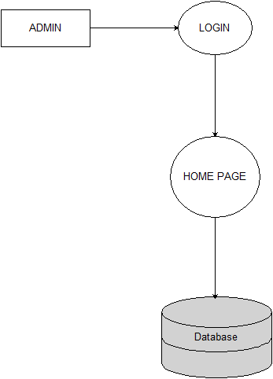

**0 LEVEL**

**1 LEVEL**

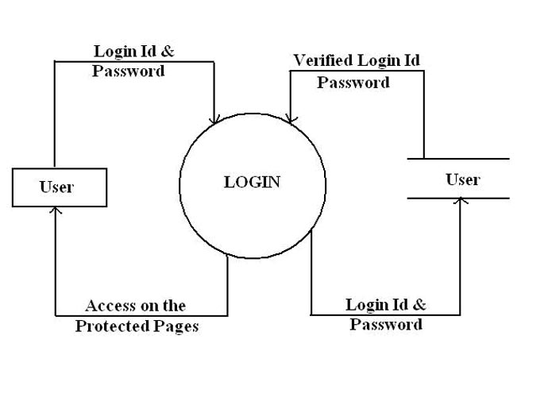

**2 LEVEL**



1. System Design

5.1Module Details

This software is designed such way that it will generate the salary automatically every month .The admin starts off from filling up the entire Employee related information and the department he is recruited. Manager assigns the employee a salary structure. And to ensure that generating and managing payroll processes for that particular Employee. There are mainly three modules in the proposed system:

**1. Administrator**: - It is concerned with all the activates in a company.

**Add Manager**- It will register all the manager of Company.

**Add salary structure**: - It will provide the salary structure.

**Add new department** :- It will add the new departments

**2. Company**: - It is mainly concerned with salary of employee.

**Add Employee**- It will register all the employee.

**Generate pay slip**: - Can generate the pay slip.

**Messages** :- can view the messages generated by employee.

**Leave Allotment** :- can allot leaves of employees.

**3. Employee**: -

1. can view their pay slip .
2. can send message to manager.
3. Can apply for leave.

5.2Database Design

5.2(i)Data Integrity Constraints

Primary Key Constraints :

A Primary key is a minimal set of candidate key that uniquely identifies all the other attributes in the relation. When declared primary key, the attribute automatically becomes unique and not null.

NOT NULL Constraints :

In websites sometimes, we would like to create an attribute that can not be left blank, i.e. we have to put some value for an attribute in order to insert a new record. This can be enforced by making use of NOT NULL Constraints.

**5.3(i) ENTITY RELATIONSHIP DIAGRAM (ERD)**

Admin

**Add**

Employee

SalaryStructure

Company

**Generate**

Payslip

5.3(ii)Database Tables

**addempTable :**

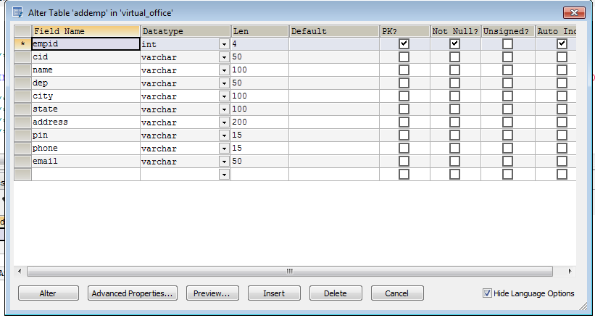

**companylogin Table :**

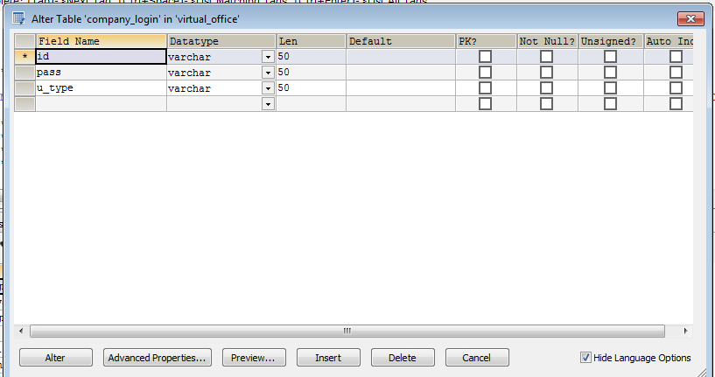

**Registration Table :**

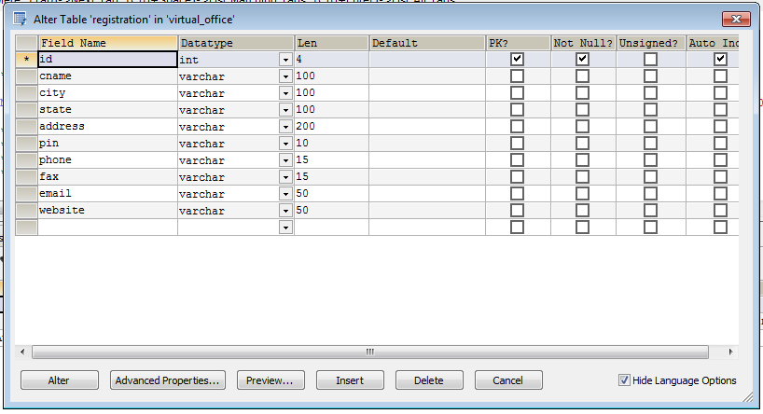

**salary :**

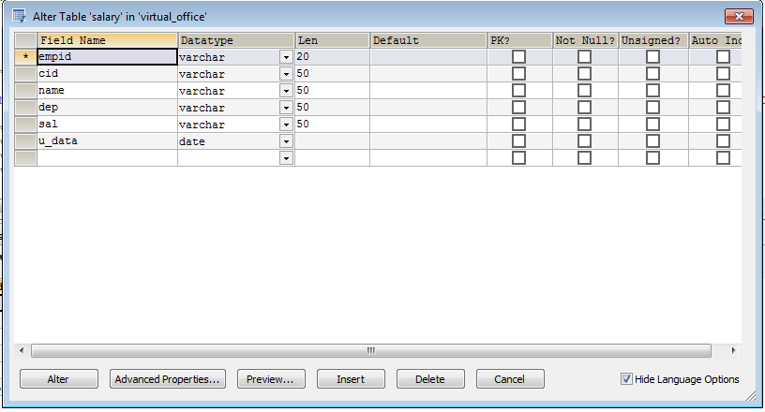

**Feedback :**

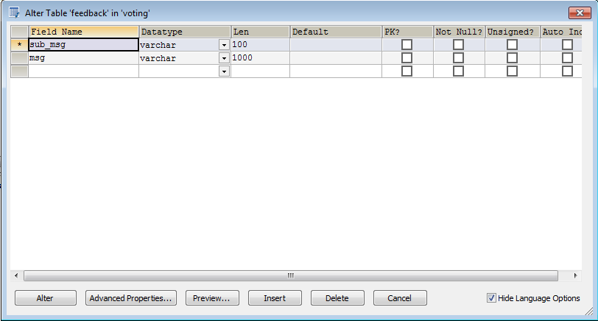

1. Screens

Home Page

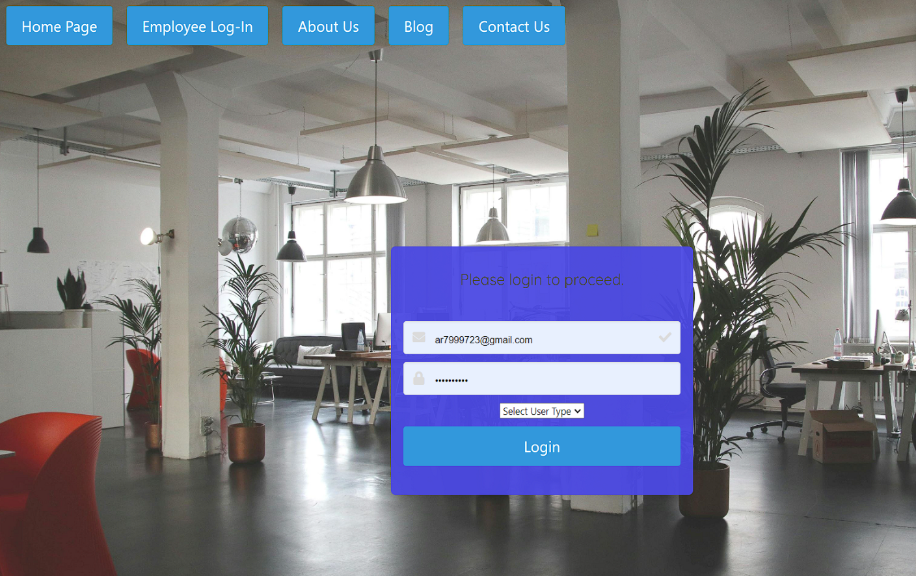

Contact Us

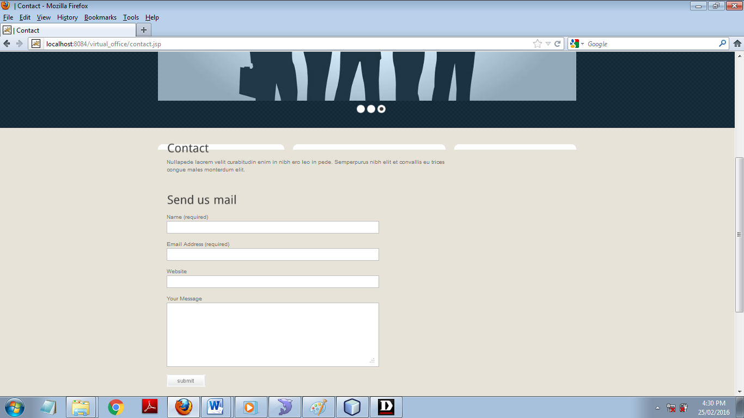

Admin Home Page

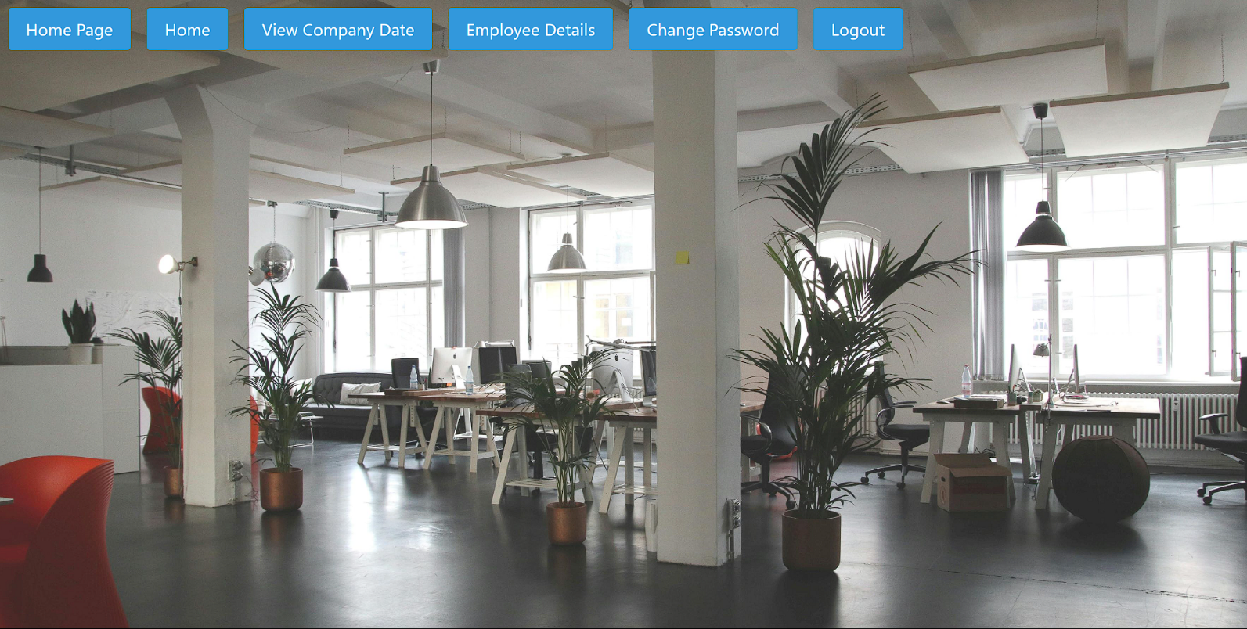

Company Data

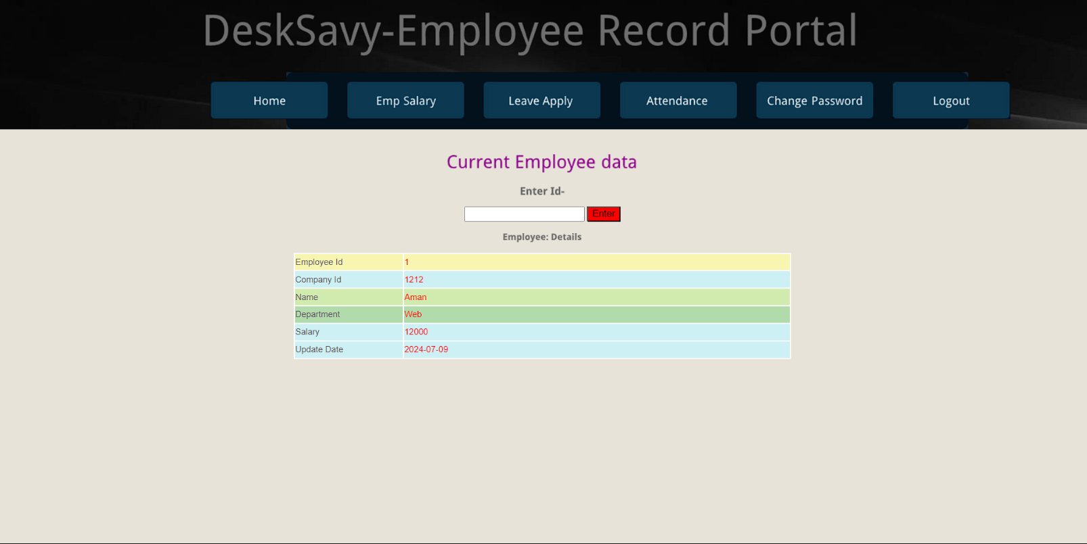

Change Admin Password

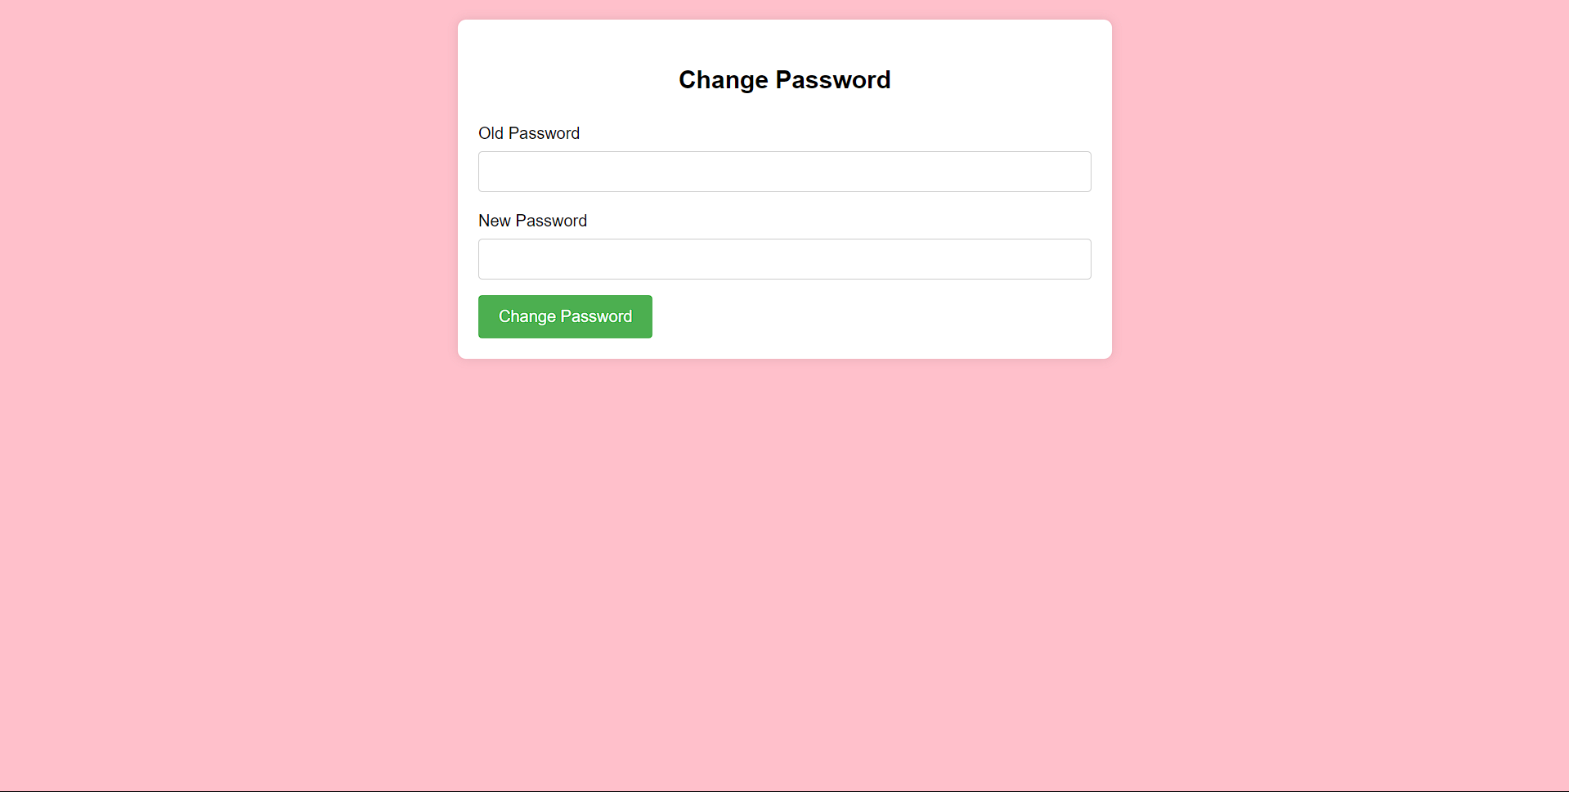

Company Home Page

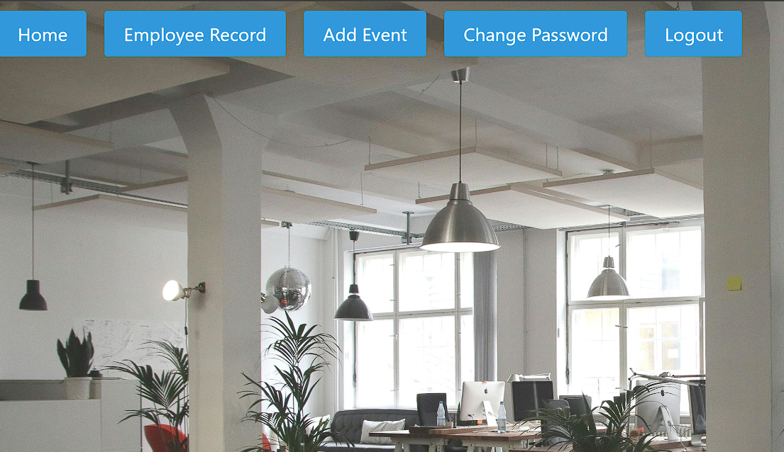

Add Employee Page

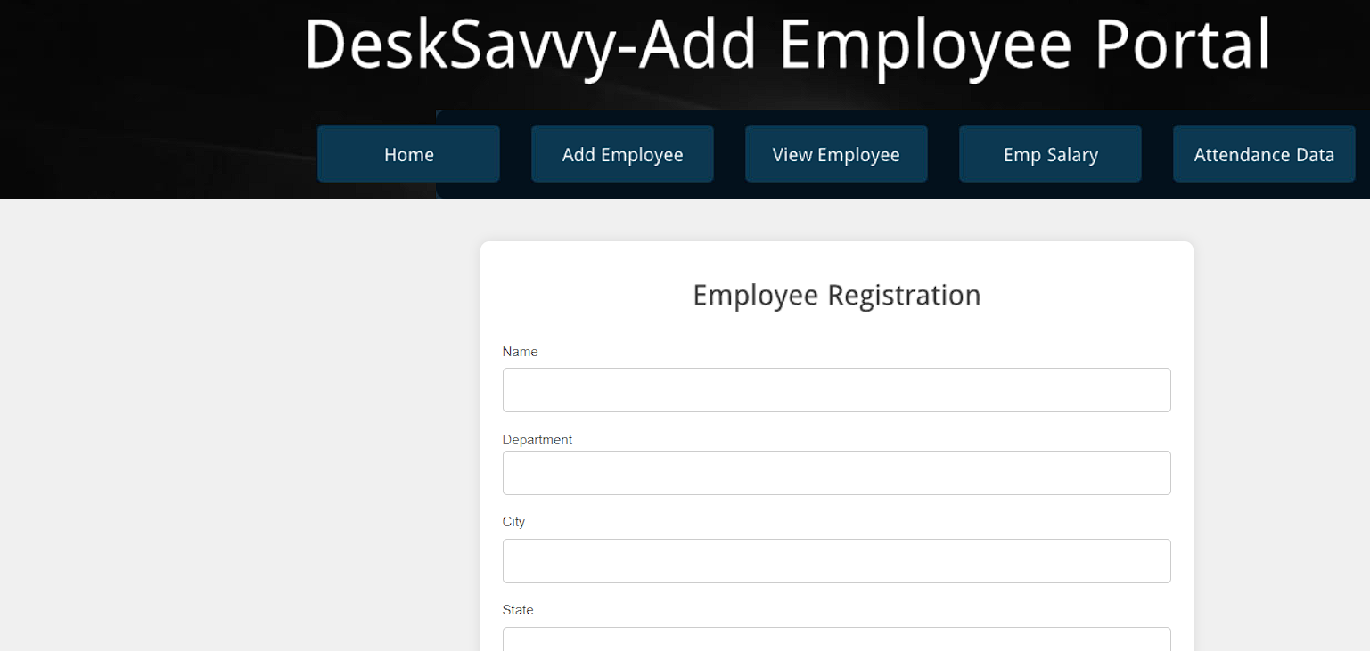

View Employee Page

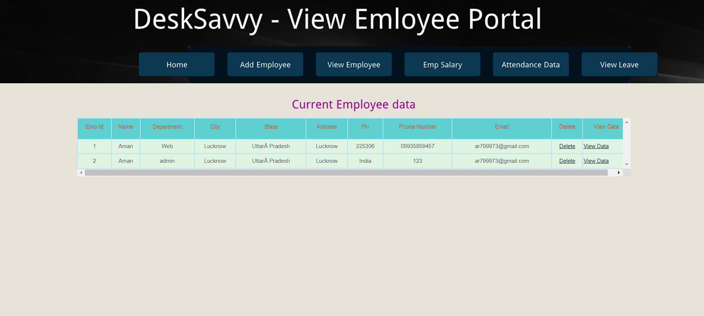

Employee Salary Slip

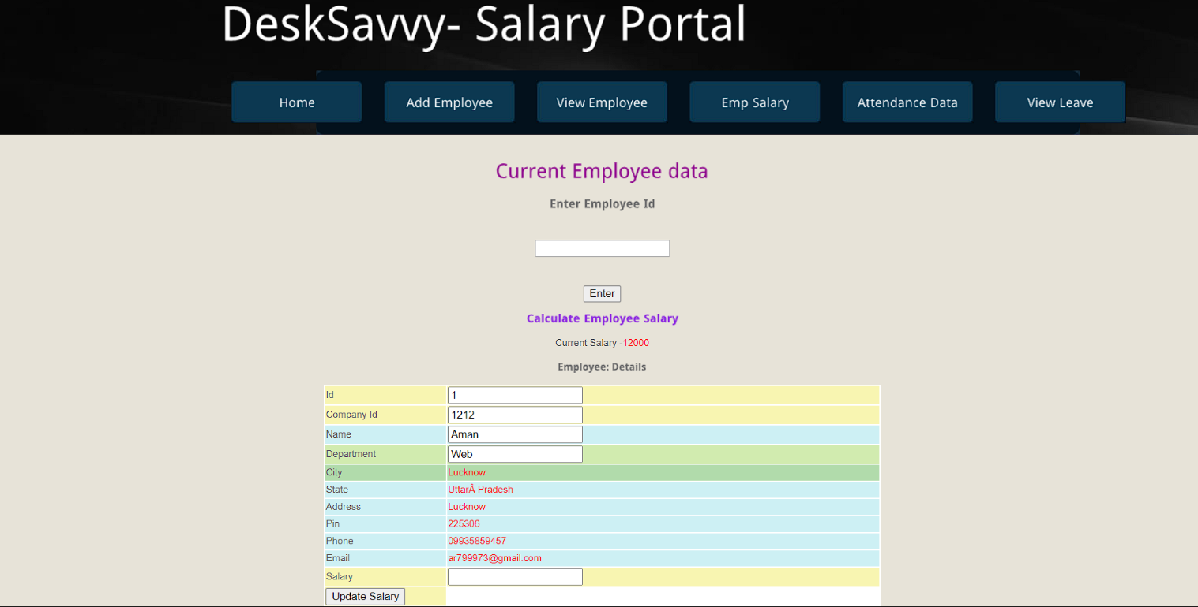

Employee Home Page



Salary Slip

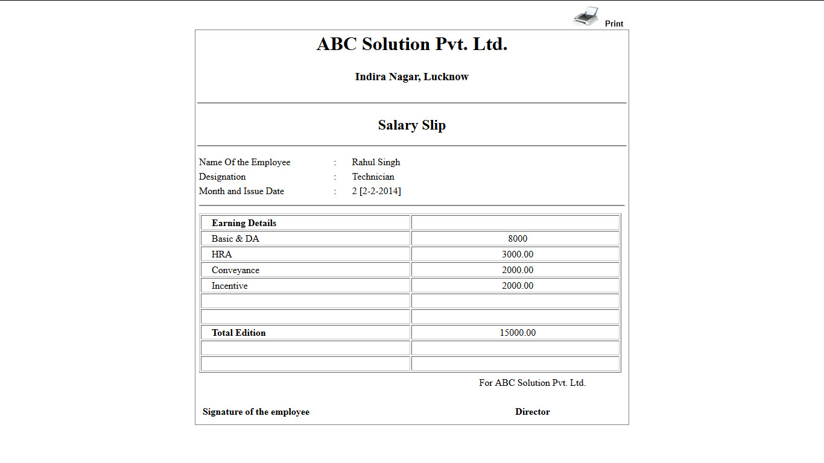

1. Coding

**DBConnection.java**

package DB;

import java.sql.*;

public class DBconnection {

public Connection con=null;

public Statement stmt=null;

public PreparedStatement pstmt=null;

public ResultSet rst=null;

public ResultSet rst1=null;

public DBconnection()

{

try

{

Class.forName("com.mysql.jdbc.Driver");

con=DriverManager.getConnection("jdbc:mysql://localhost:3306/virtual_office","root","root");

}

catch(Exception e)

{

e.printStackTrace();

}

}

}

**Index.jsp**

<%@page contentType="text/html" pageEncoding="UTF-8"%>

<!DOCTYPE html PUBLIC "-//W3C//DTD XHTML 1.0 Transitional//EN" "http://www.w3.org/TR/xhtml1/DTD/xhtml1-transitional.dtd">

<html xmlns="http://www.w3.org/1999/xhtml">

<head>

<title>DeskSavvy</title>

<meta http-equiv="Content-Type" content="text/html; charset=utf-8" />

<link href="css/style.css" rel="stylesheet" type="text/css" />

<link rel="stylesheet" type="text/css" href="css/coin-slider.css" />

<script type="text/javascript" src="js/cufon-yui.js"></script>

<script type="text/javascript" src="js/droid_sans_400-droid_sans_700.font.js"></script>

<script type="text/javascript" src="js/jquery-1.4.2.min.js"></script>

<script type="text/javascript" src="js/script.js"></script>

<script type="text/javascript" src="js/coin-slider.min.js"></script>

</head>

<body>

<div class="main">

<div class="header">

<div class="header_resize">

<div class="logo">

<h1><a href="index.html"><span>Virtual</span>Office System</a></h1>

</div>

<div class="clr"></div>

<div class="menu_nav" style="width:1000px; ">

<ul>

<li class="active"><a href="index.jsp"><span>Home Page</span></a></li>

<li><a href="support.jsp"><span>Support</span></a></li>

<li><a href="about.jsp"><span>About Us</span></a></li>

<li><a href="blog.jsp"><span>Blog</span></a></li>

<li><a href="contact.jsp"><span>Contact Us</span></a></li>

</ul>

</div>

<div class="clr"></div>

<div class="slider" >

<div id="coin-slider"><a href="#"><img src="images/slide1.jpg" width="960" height="360" alt="" /></a><a href="#"><img src="images/slide2.jpg" width="960" height="360" alt="" /></a><a href="#"><img src="images/slide3.jpg" width="960" height="360" alt="" /></a></div>

<div class="clr"></div>

</div>

<div class="clr"></div>

</div>

</div></br></br></br>

<center>

<div style="width:300px;height:250px;">

<form action="login" method="get">

<fieldset style="width: 300px;height: 250px;">

<legand><h2 style="color:green;">User Login</h2></legand>

<table width=200px, height="150px">

<tr width="30px" height="30px"><td width="10px"></td><td width="10px" align="center"><select name="t1" style="width: 140px;height: 70;background-color: #A0EDE5;"><option>Select user type..</option><option value="admin">Admin</option><option value="company">Company</option><option value="emp">Employee</option></select></td><td width="10px"></td></tr>

<tr><td width="30px" align=center><lable>User_Id-</lable><lable style="color:red;">*</lable><td><input type=text name="t2"/></td></tr><tr height="10px"></tr>

<tr><td width="30px" align=left><lable>Password-</lable><lable style="color:red;">*</lable></td><td><input type=password name="t3"/></td></tr><tr height="5px"></tr>

<tr width="30px"><td width="10px"></td><td width="10px" align="center"><input type="submit" value="LogIn" style="width:70px;height: 25px;background-color: #ACF7D1;"></td><td width="10px"></td></tr>

<tr height="10px"></tr><tr width="30px" height="20px"><td width="10px"></td><td width="10px" align="center"><a href="registration.jsp"><h3>New Registration..</h3></a></td><td width="10px"></td></tr>

<%

String m=request.getParameter("msg");

if(m!=null)

out.println("<p style='color:red'>"+m+"</p>");

%>

</table>

</fieldset>

</form>

</div>

</center>

<div class="clr"></div>

</div>

</div>

<div class="fbg">

<div class="fbg_resize">

<div class="col c1">

<h2><span>Image</span> Gallery</h2>

<a href="#"><img src="images/gal1.jpg" width="75" height="75" alt="" class="gal" /></a><a href="#"><img src="images/gal2.jpg" width="75" height="75" alt="" class="gal" /></a><a href="#"><img src="images/gal3.jpg" width="75" height="75" alt="" class="gal" /></a><a href="#"><img src="images/gal4.jpg" width="75" height="75" alt="" class="gal" /></a><a href="#"><img src="images/gal5.jpg" width="75" height="75" alt="" class="gal" /></a><a href="#"><img src="images/gal6.jpg" width="75" height="75" alt="" class="gal" /></a></div>

<div class="col c2">

<h2><span>Services</span> Overview</h2>

<p>Curabitur sed urna id nunc pulvinar semper. Nunc sit amet tortor sit amet lacus sagittis posuere cursus vitae nunc.Etiam venenatis, turpis at eleifend porta, nisl nulla bibendum justo.</p>

<ul class="fbg_ul">

<li><a href="#">Lorem ipsum dolor labore et dolore.</a></li>

<li><a href="#">Excepteur officia deserunt.</a></li>

<li><a href="#">Integer tellus ipsum tempor sed.</a></li>

</ul>

</div>

<div class="col c3">

<h2><span>Contact</span> Us</h2>

<p></p>

<p class="contact_info"><span>Address:</span><br />

<span>&nbsp;</span><br />

<span></span><br />

<span>FAX:</span><br />

<span>E-mail:</span><a href="#"></a></p>

</div>

<div class="clr"></div>

</div>

</div>

<div class="footer">

<div class="footer_resize">

<p class="lf">&copy; Copyright <a href="#"></a>.</p>

<div style="clear:both;"></div>

</div>

</div>

</div>

</body>

</html>

**Login.java(servlet) :**

/*

* To change this license header, choose License Headers in Project Properties.

* To change this template file, choose Tools | Templates

* and open the template in the editor.

*/

import DB.DBconnection;

import java.io.IOException;

import java.io.PrintWriter;

import javax.servlet.ServletException;

import javax.servlet.http.HttpServlet;

import javax.servlet.http.HttpServletRequest;

import javax.servlet.http.HttpServletResponse;

import javax.servlet.http.HttpSession;

public class login extends HttpServlet {

/**

* Processes requests for both HTTP <code>GET</code> and <code>POST</code>

* methods.

*

* @param request servlet request

* @param response servlet response

* @throws ServletException if a servlet-specific error occurs

* @throws IOException if an I/O error occurs

*/

protected void processRequest(HttpServletRequest request, HttpServletResponse response)

throws ServletException, IOException {

response.setContentType("text/html;charset=UTF-8");

try (PrintWriter out = response.getWriter()) {

HttpSession st=request.getSession();

String type=request.getParameter("t1");

String user=request.getParameter("t2");

String pass=request.getParameter("t3");

out.println(type);

out.println(user);

DBconnection db=new DBconnection();

db.pstmt=db.con.prepareStatement("select u_type from company_login where id='"+user+"' and pass='"+pass+"'");

db.rst= db.pstmt.executeQuery();

if(db.rst.next())

{

String type1=db.rst.getString(1);

if(type1.equals(type)&&type1.equals("company"))

{

st.setAttribute("user1", user);

st.setAttribute("pass1", pass);

//st.setAttribute("type1",type1);

response.sendRedirect("office_home.jsp");

}

else

if(type1.equals(type)&&type1.equals("emp"))

{

st.setAttribute("user2", user);

st.setAttribute("pass2", pass);

// st.setAttribute("type2",type1);

response.sendRedirect("empHome.jsp");

}

else

if(type1.equals(type)&&type1.equals("admin"))

{

st.setAttribute("user3", user);

st.setAttribute("pass3", pass);

// st.setAttribute("type2",type1);

response.sendRedirect("adminHome.jsp");

}

else{

response.sendRedirect("index.jsp?msg=Invalid User TYPE!!!");

}

}

else{

response.sendRedirect("index.jsp?msg=Invalid User id and password!!!");

}

} catch(Exception e) {

e.printStackTrace();

}

}

// <editor-fold defaultstate="collapsed" desc="HttpServlet methods. Click on the + sign on the left to edit the code.">

/**

* Handles the HTTP <code>GET</code> method.

*

* @param request servlet request

* @param response servlet response

* @throws ServletException if a servlet-specific error occurs

* @throws IOException if an I/O error occurs

*/

@Override

protected void doGet(HttpServletRequest request, HttpServletResponse response)

throws ServletException, IOException {

processRequest(request, response);

}

/**

* Handles the HTTP <code>POST</code> method.

*

* @param request servlet request

* @param response servlet response

* @throws ServletException if a servlet-specific error occurs

* @throws IOException if an I/O error occurs

*/

@Override

protected void doPost(HttpServletRequest request, HttpServletResponse response)

throws ServletException, IOException {

processRequest(request, response);

}

@Override

public String getServletInfo() {

return "Short description";

}// </editor-fold>

}

**PasswordChange.java :**

import DB.DBconnection;

import java.io.IOException;

import java.io.PrintWriter;

import javax.servlet.ServletException;

import javax.servlet.http.HttpServlet;

import javax.servlet.http.HttpServletRequest;

import javax.servlet.http.HttpServletResponse;

import javax.servlet.http.HttpSession;

public class Com_changepassword1 extends HttpServlet {

protected void processRequest(HttpServletRequest request, HttpServletResponse response)

throws ServletException, IOException {

response.setContentType("text/html;charset=UTF-8");

try (PrintWriter out = response.getWriter()) {

/* TODO output your page here. You may use following sample code. */

HttpSession st=request.getSession(true);

String old=request.getParameter("t1");

String npass=request.getParameter("t2");

String user=(String)st.getAttribute("user1");

DBconnection db=new DBconnection();

db.pstmt=db.con.prepareStatement("select pass from company_login where id='"+user+"'");

db.rst=db.pstmt.executeQuery();

if(db.rst.next())

{

String pass=db.rst.getString(1);

if(pass.equals(old))

{

db.pstmt=db.con.prepareStatement("update company_login set pass=? where id='"+user+"'");

db.pstmt.setString(1, npass);

int i=db.pstmt.executeUpdate();

if(i>0)

{

response.sendRedirect("CompanyChanPass.jsp?msg=Password change successfull..");

}

}

else

{

response.sendRedirect("CompanyChanPass.jsp?msg=Old Password not match!!!!");

}

}

} catch(Exception e) {

e.printStackTrace();

}

}

// <editor-fold defaultstate="collapsed" desc="HttpServlet methods. Click on the + sign on the left to edit the code.">

/**

* Handles the HTTP <code>GET</code> method.

*

* @param request servlet request

* @param response servlet response

* @throws ServletException if a servlet-specific error occurs

* @throws IOException if an I/O error occurs

*/

@Override

protected void doGet(HttpServletRequest request, HttpServletResponse response)

throws ServletException, IOException {

processRequest(request, response);

}

/**

* Handles the HTTP <code>POST</code> method.

*

* @param request servlet request

* @param response servlet response

* @throws ServletException if a servlet-specific error occurs

* @throws IOException if an I/O error occurs

*/

@Override

protected void doPost(HttpServletRequest request, HttpServletResponse response)

throws ServletException, IOException {

processRequest(request, response);

}

/**

* Returns a short description of the servlet.

*

* @return a String containing servlet description

*/

@Override

public String getServletInfo() {

return "Short description";

}// </editor-fold>

}

**AddEmp.java :**

import DB.DBconnection;

import java.io.IOException;

import java.io.PrintWriter;

import javax.servlet.ServletException;

import javax.servlet.http.HttpServlet;

import javax.servlet.http.HttpServletRequest;

import javax.servlet.http.HttpServletResponse;

import javax.servlet.http.HttpSession;

public class addemp extends HttpServlet {

protected void processRequest(HttpServletRequest request, HttpServletResponse response)

throws ServletException, IOException {

response.setContentType("text/html;charset=UTF-8");

try (PrintWriter out = response.getWriter()) {

/* TODO output your page here. You may use following sample code. */

HttpSession st=request.getSession(true);

String user=(String)st.getAttribute("user1");

String hname=request.getParameter("t1");

String ownername=request.getParameter("t2");

String city=request.getParameter("t3");

String reg=request.getParameter("t4");

String room=request.getParameter("t5");

String pin=request.getParameter("t6");

String phone=request.getParameter("t7");

String fax=request.getParameter("t8");

String u_typ="emp";

DBconnection db=new DBconnection();

db.pstmt=db.con.prepareStatement("insert into addemp(cid,name,dep,city,state,address,pin,phone,email) values(?,?,?,?,?,?,?,?,?)");

db.pstmt.setString(1, user);

db.pstmt.setString(2, hname);

db.pstmt.setString(3, ownername);

db.pstmt.setString(4, city);

db.pstmt.setString(5, reg);

db.pstmt.setString(6 ,room);

db.pstmt.setString(7, pin);

db.pstmt.setString(8, phone);

db.pstmt.setString(9, fax);

int x=db.pstmt.executeUpdate();

if(x>0)

{

db.pstmt=db.con.prepareStatement("insert into company_login(id,pass,u_type) values(?,?,?)");

db.pstmt.setString(1, fax);

db.pstmt.setString(2, hname);

db.pstmt.setString(3, u_typ);

int y=db.pstmt.executeUpdate();

if(y>0)

{

response.sendRedirect("addEmp.jsp?msg=Employee Registration Complete!!!!!!!...!!");

}

else

{

response.sendRedirect("addEmp.jsp?msg=User already Registred...!!...!!");

}

}

else

{

response.sendRedirect("addEmp.jsp?msg=User already Registred...!!");

}

} catch(Exception e) {

response.sendRedirect("addEmp.jsp?msg=Please fill data proper way...!!");

}

}

// <editor-fold defaultstate="collapsed" desc="HttpServlet methods. Click on the + sign on the left to edit the code.">

/**

* Handles the HTTP <code>GET</code> method.

*

* @param request servlet request

* @param response servlet response

* @throws ServletException if a servlet-specific error occurs

* @throws IOException if an I/O error occurs

*/

@Override

protected void doGet(HttpServletRequest request, HttpServletResponse response)

throws ServletException, IOException {

processRequest(request, response);

}

/**

* Handles the HTTP <code>POST</code> method.

*

* @param request servlet request

* @param response servlet response

* @throws ServletException if a servlet-specific error occurs

* @throws IOException if an I/O error occurs

*/

@Override

protected void doPost(HttpServletRequest request, HttpServletResponse response)

throws ServletException, IOException {

processRequest(request, response);

}

/**

* Returns a short description of the servlet.

*

* @return a String containing servlet description

*/

@Override

public String getServletInfo() {

return "Short description";

}// </editor-fold>

}

**Delete.java**

import DB.DBconnection;

import java.io.IOException;

import java.io.PrintWriter;

import javax.servlet.ServletException;

import javax.servlet.http.HttpServlet;

import javax.servlet.http.HttpServletRequest;

import javax.servlet.http.HttpServletResponse;

public class delete extends HttpServlet {

protected void processRequest(HttpServletRequest request, HttpServletResponse response)

throws ServletException, IOException {

response.setContentType("text/html;charset=UTF-8");

try (PrintWriter out = response.getWriter()) {

String code=request.getParameter("id");

DBconnection db=new DBconnection();

db.pstmt=db.con.prepareStatement("delete from addemp where empid='"+code+"'");

//db.pstmt.setString(1,code);

int i=db.pstmt.executeUpdate();

if(i>0)

{

response.sendRedirect("viewemp.jsp?msg=Employee Record Delete Complete!!!!!!!...!!");

}

else

{

response.sendRedirect("viewemp.jsp?msg= Error!!!!!!!...!!");

}

} catch(Exception e) {

e.printStackTrace();

}

}

// <editor-fold defaultstate="collapsed" desc="HttpServlet methods. Click on the + sign on the left to edit the code.">

/**

* Handles the HTTP <code>GET</code> method.

*

* @param request servlet request

* @param response servlet response

* @throws ServletException if a servlet-specific error occurs

* @throws IOException if an I/O error occurs

*/

@Override

protected void doGet(HttpServletRequest request, HttpServletResponse response)

throws ServletException, IOException {

processRequest(request, response);

}

/**

* Handles the HTTP <code>POST</code> method.

*

* @param request servlet request

* @param response servlet response

* @throws ServletException if a servlet-specific error occurs

* @throws IOException if an I/O error occurs

*/

@Override

protected void doPost(HttpServletRequest request, HttpServletResponse response)

throws ServletException, IOException {

processRequest(request, response);}}}

**salary.java:**

import DB.DBconnection;

import java.io.IOException;

import java.io.PrintWriter;

import javax.servlet.ServletException;

import javax.servlet.http.HttpServlet;

import javax.servlet.http.HttpServletRequest;

import javax.servlet.http.HttpServletResponse;

import javax.servlet.http.HttpSession;

public class salary extends HttpServlet {

/**

* Processes requests for both HTTP <code>GET</code> and <code>POST</code>

* methods.

*

* @param request servlet request

* @param response servlet response

* @throws ServletException if a servlet-specific error occurs

* @throws IOException if an I/O error occurs

*/

protected void processRequest(HttpServletRequest request, HttpServletResponse response)

throws ServletException, IOException {

response.setContentType("text/html;charset=UTF-8");

try (PrintWriter out = response.getWriter()) {

/* TODO output your page here. You may use following sample code. */

String hname=request.getParameter("t1");

String ownername=request.getParameter("t2");

String city=request.getParameter("t3");

String reg=request.getParameter("t4");

HttpSession st=request.getSession();

String user=(String)st.getAttribute("user1");

DBconnection db=new DBconnection();

db.pstmt=db.con.prepareStatement("insert into salary(empid,cid,name,dep,sal,u_data) values(?,?,?,?,?,curdate())");

db.pstmt.setString(1, hname);

db.pstmt.setString(2, user);

db.pstmt.setString(3, ownername);

db.pstmt.setString(4, city);

db.pstmt.setString(5, reg);

int x=db.pstmt.executeUpdate();

if(x>0)

{

response.sendRedirect("empsal.jsp?msg=Employee Salary Update ...!!");

}

}

catch(Exception e) {

e.printStackTrace();

}

}

// <editor-fold defaultstate="collapsed" desc="HttpServlet methods. Click on the + sign on the left to edit the code.">

/**

* Handles the HTTP <code>GET</code> method.

*

* @param request servlet request

* @param response servlet response

* @throws ServletException if a servlet-specific error occurs

* @throws IOException if an I/O error occurs

*/

@Override

protected void doGet(HttpServletRequest request, HttpServletResponse response)

throws ServletException, IOException {

processRequest(request, response);

}

/**

* Handles the HTTP <code>POST</code> method.

*

* @param request servlet request

* @param response servlet response

* @throws ServletException if a servlet-specific error occurs

* @throws IOException if an I/O error occurs

*/

@Override

protected void doPost(HttpServletRequest request, HttpServletResponse response)

throws ServletException, IOException {

processRequest(request, response);

}

/**

* Returns a short description of the servlet.

*

* @return a String containing servlet description

*/

@Override

public String getServletInfo() {

return "Short description";

}// </editor-fold>

}

**addEmp.jsp:**

<%@page contentType="text/html" pageEncoding="UTF-8"%>

<!DOCTYPE html PUBLIC "-//W3C//DTD XHTML 1.0 Transitional//EN" "http://www.w3.org/TR/xhtml1/DTD/xhtml1-transitional.dtd">

<html xmlns="http://www.w3.org/1999/xhtml">

<head>

<title>DeskSavvy</title>

<meta http-equiv="Content-Type" content="text/html; charset=utf-8" />

<link href="css/style.css" rel="stylesheet" type="text/css" />

<link rel="stylesheet" type="text/css" href="css/coin-slider.css" />

<script type="text/javascript" src="js/cufon-yui.js"></script>

<script type="text/javascript" src="js/droid_sans_400-droid_sans_700.font.js"></script>

<script type="text/javascript" src="js/jquery-1.4.2.min.js"></script>

<script type="text/javascript" src="js/script.js"></script>

<script type="text/javascript" src="js/coin-slider.min.js"></script>

</head>

<body>

<%

HttpSession st=request.getSession();

String user=(String)st.getAttribute("user1");

String pass=(String)st.getAttribute("pass1");

if(user==null||pass==null)

response.sendRedirect("index.jsp?msg=Please login first!!!!");

%>

<div class="main">

<div class="header">

<div class="header_resize">

<div class="logo">

<h1><a href="index.html"><span>Virtual</span>Office</a></h1>

</div>

<div class="clr"></div>

<div class="menu_nav">

<ul>

<li class="active"><a href="office_home.jsp"><span>Home</span></a></li>

<li><a href="addEmp.jsp"><span>Add Employee</span></a></li>

<li><a href="viewemp.jsp"><span>View Employee</span></a></li>

<li><a href="empsal.jsp"><span>Emp Salary</span></a></li>

<li><a href="logout"><span>Logout</span></a></li>

</ul>

</div></div>

</div>

</div>

<div class="clr"></div>

<center>

<div style="width:1000px;height: 650px;background-color: white;">

<form method="post" action="addemp" name="frm" onsubmit="return abc();">

<fieldset width="100px" height=200px">

<h2 style="color:blue;">Employee Registration </h2>

<table style="width:600px;height:400px; background-color: white;">

<tr height="30px"><td align="right">Name<lable style="color:red;">* </lable></td><td width="20px"></td><td><input type="text" name="t1" style="height: 20px"/></td></tr><br>

<tr height="30px"><td align="right">Department<lable style="color:red;">* </lable></td><td width="20px"></td><td><input type="text" name="t2" style="height: 20px"/></td></tr><br>

<tr height="30px"><td align="right">City<lable style="color:red;">* </lable></td><td width="20px"></td><td><input type="text" name="t3" style="height: 20px"/></td></tr>

<tr height="30px"><td align="right">State<lable style="color:red;">* </lable></td><td width="20px"></td><td><input type="text" name="t4" style="height: 20px"/></td></tr>

<tr height="30px"><td align="right">Address<lable style="color:red;">* </lable></td><td width="20px"></td><td><textarea name="t5" style="height: 70px;width: 220px;"></textarea></td></tr>

<tr height="30px"><td align="right">Pin<lable style="color:red;">* </lable></td><td width="20px"></td><td><input type="number" name="t6" style="height: 20px"/></td></tr>

<tr height="30px"><td align="right">Phone No<lable style="color:red;">* </lable></td><td width="20px"></td><td><input type="number" name="t7" style="height: 20px"/></td></tr>

<tr height="30px"><td align="right">Email_id<lable style="color:red;">* </lable></td><td width="20px"></td><td><input type="email" name="t8" style="height: 20px"/></td><lable style="color:red;">(Note- Employee password are employee name)</lable></tr>

</table>

<tr height="30px"></tr><tr height="30px"><td><input type="submit" value="Submit" style="width:90px;height: 25px;background-color:lightpink;"></td><td width="20px"></td><td></td></tr>

<br></br><%

String m=request.getParameter("msg");

if(m!=null)

out.println("<p style='color:red';>"+m+"</p>");

%>

</fieldset>

</form>

</div>

</center>

</body>

</html>

**Contact.jsp :**

<%@page contentType="text/html" pageEncoding="UTF-8"%>

<!DOCTYPE html PUBLIC "-//W3C//DTD XHTML 1.0 Transitional//EN" "http://www.w3.org/TR/xhtml1/DTD/xhtml1-transitional.dtd">

<html xmlns="http://www.w3.org/1999/xhtml">

<head>

<title>| Contact</title>

<meta http-equiv="Content-Type" content="text/html; charset=utf-8" />

<link href="css/style.css" rel="stylesheet" type="text/css" />

<link rel="stylesheet" type="text/css" href="css/coin-slider.css" />

<script type="text/javascript" src="js/cufon-yui.js"></script>

<script type="text/javascript" src="js/droid_sans_400-droid_sans_700.font.js"></script>

<script type="text/javascript" src="js/jquery-1.4.2.min.js"></script>

<script type="text/javascript" src="js/script.js"></script>

<script type="text/javascript" src="js/coin-slider.min.js"></script>

</head>

<body>

<div class="main">

<div class="header">

<div class="header_resize">

<div class="searchform">

<form id="formsearch" name="formsearch" method="post" action="#">

<span>

<input name="editbox_search" class="editbox_search" id="editbox_search" maxlength="80" value="Search our ste:" type="text" />

</span>

<input name="button_search" src="images/search.gif" class="button_search" type="image" />

</form>

</div>

<div class="logo">

<h1><a href="index.html"><span>Virtual</span>Office</a></h1>

</div>

<div class="clr"></div>

<div class="menu_nav">

<ul>

<li><a href="index.jsp"><span>Home Page</span></a></li>

<li><a href="support.jsp"><span>Support</span></a></li>

<li><a href="about.jsp"><span>About Us</span></a></li>

<li><a href="blog.jsp"><span>Blog</span></a></li>

<li class="active"><a href="contact.jsp"><span>Contact Us</span></a></li>

</ul>

</div>

<div class="clr"></div>

<div class="slider">

<div id="coin-slider"><a href="#"><img src="images/slide1.jpg" width="960" height="360" alt="" /></a><a href="#"><img src="images/slide2.jpg" width="960" height="360" alt="" /></a><a href="#"><img src="images/slide3.jpg" width="960" height="360" alt="" /></a></div>

<div class="clr"></div>

</div>

<div class="clr"></div>

</div>

</div>

<div class="content">

<div class="content_resize">

<div class="mainbar">

<div class="article">

<h2><span>Contact</span></h2>

<div class="clr"></div>

<p>Nullapede laorem velit curabitudin enim in nibh ero leo in pede. Semperpurus nibh elit et convallis eu trices congue males monterdum elit.</p>

</div>

<div class="article">

<h2><span>Send us</span> mail</h2>

<div class="clr"></div>

<form action="#" method="post" id="sendemail">

<ol>

<li>

<label for="name">Name (required)</label>

<input id="name" name="name" class="text" />

</li>

<li>

<label for="email">Email Address (required)</label>

<input id="email" name="email" class="text" />

</li>

<li>

<label for="website">Website</label>

<input id="website" name="website" class="text" />

</li>

<li>

<label for="message">Your Message</label>

<textarea id="message" name="message" rows="8" cols="50"></textarea>

</li>

<li>

<input type="image" name="imageField" id="imageField" src="images/submit.gif" class="send" />

<div class="clr"></div>

</li>

</ol>

</form>

</div>

</div>

</div>

<div class="clr"></div>

</div>

</div>

<div class="fbg">

<div class="fbg_resize">

<div class="col c1">

<h2><span>Image</span> Gallery</h2>

<a href="#"><img src="images/gal1.jpg" width="75" height="75" alt="" class="gal" /></a><a href="#"><img src="images/gal2.jpg" width="75" height="75" alt="" class="gal" /></a><a href="#"><img src="images/gal3.jpg" width="75" height="75" alt="" class="gal" /></a><a href="#"><img src="images/gal4.jpg" width="75" height="75" alt="" class="gal" /></a><a href="#"><img src="images/gal5.jpg" width="75" height="75" alt="" class="gal" /></a><a href="#"><img src="images/gal6.jpg" width="75" height="75" alt="" class="gal" /></a></div>

<div class="col c2">

<h2><span>Services</span> Overview</h2>

<p>Curabitur sed urna id nunc pulvinar semper. Nunc sit amet tortor sit amet lacus sagittis posuere cursus vitae nunc.Etiam venenatis, turpis at eleifend porta, nisl nulla bibendum justo.</p>

<ul class="fbg_ul">

<li><a href="#">Lorem ipsum dolor labore et dolore.</a></li>

<li><a href="#">Excepteur officia deserunt.</a></li>

<li><a href="#">Integer tellus ipsum tempor sed.</a></li>

</ul>

</div>

<div class="col c3">

<h2><span>Contact</span> Us</h2>

<p></p>

<p class="contact_info"><span>Address:</span><br />

<span>&nbsp;</span><br />

<span></span><br />

<span>FAX:</span><br />

<span>E-mail:</span><a href="#"></a></p>

</div>

<div class="clr"></div>

</div>

</div>

<div class="footer">

<div class="footer_resize">

<p class="lf">&copy; Copyright <a href="#"></a>.</p>

<div style="clear:both;"></div>

</div>

</div>

</div>

</html>

**EmpHome.jsp :**

<%@page contentType="text/html" pageEncoding="UTF-8"%>

<!DOCTYPE html PUBLIC "-//W3C//DTD XHTML 1.0 Transitional//EN" "http://www.w3.org/TR/xhtml1/DTD/xhtml1-transitional.dtd">

<html xmlns="http://www.w3.org/1999/xhtml">

<head>

<title>DeskSavvy</title>

<meta http-equiv="Content-Type" content="text/html; charset=utf-8" />

<link href="css/style.css" rel="stylesheet" type="text/css" />

<link rel="stylesheet" type="text/css" href="css/coin-slider.css" />

<script type="text/javascript" src="js/cufon-yui.js"></script>

<script type="text/javascript" src="js/droid_sans_400-droid_sans_700.font.js"></script>

<script type="text/javascript" src="js/jquery-1.4.2.min.js"></script>

<script type="text/javascript" src="js/script.js"></script>

<script type="text/javascript" src="js/coin-slider.min.js"></script>

</head>

<body>

<%

HttpSession st=request.getSession();

String user=(String)st.getAttribute("user2");

String pass=(String)st.getAttribute("pass2");

if(user==null||pass==null)

response.sendRedirect("index.jsp?msg=Please login first!!!!");

%>

<div class="main">

<div class="header">

<div class="header_resize">

<div class="logo">

<h1><a href="index.html"><span>Virtual</span>Office System</a></h1>

</div>

<div class="clr"></div>

<div class="menu_nav">

<ul>

<li class="active"><a href="empHome.jsp"><span>Home</span></a></li>

<li><a href="empsal11.jsp"><span>Emp Salary</span></a></li>

<li><a href="empchangePass.jsp"><span>Change Password</span></a></li>

<li><a href="emplogout"><span>Logout</span></a></li>

</ul>

</div></div>

</div>

</div>

<div class="clr"></div>

<%

out.println("<h2 style='color:green;'>Welcome to <span>"+user+"</span></h2>");

%>

</body>

</html>

**setStatus.jsp :**

<%@page contentType="text/html" pageEncoding="UTF-8"%>

<!DOCTYPE html>

<html>

<head>

<meta http-equiv="Content-Type" content="text/html; charset=UTF-8">

<title>Change_password</title>

</head>

<body>

<%

HttpSession st=request.getSession();

String user=(String)st.getAttribute("user2");

String pass=(String)st.getAttribute("pass2");

if(user==null||pass==null)

response.sendRedirect("index.jsp?msg=Please login first!!!!");

%>

<center>

<div style="width:900px;height: 120px;background-image: url('images/66.jpg');">

</div>

<h3><p align="left"><a href="empHome.jsp">Back</a></p></h3>

<div style="width: 600px;height: 300px;background-color: white;">

<form method="post" action="changepassword1">

<fieldset width="100px" height="400px">

<legend><h1 style="color: orange;">Change Password</h1></legend>

<table>

<br></br>

<tr height="30px"><td>Old_Password</td><td width="20px"></td><td><input type="password" name="t1" style="height: 20px"></td></tr>

<tr height="30px"><td> New_Password</td><td width="20px"></td><td><input type="password" name="t2"style="height: 20px"></td></tr>

<tr height="30px"></tr><tr height="30px"><td><input type="submit"value="Change"style="width:90px;height: 30px ;background-color:lightskyblue;"></td><td width="20px"></td><td><input type="reset" value="Clear" style="width: 90px ;height: 30px;background-color: indianred;"></td></tr>

<tr height="50px"><td>

<%

String abc=request.getParameter("msg");

if(abc!=null)

out.println("<h4 style='color:green;'>"+abc+"</h4>");

%>

</table>

</fieldset>

</form>

</div>

</center>

</body>

</html>

**EmpSal.jsp :**

<%@page import="DB.DBconnection"%>

<%@page contentType="text/html" pageEncoding="UTF-8"%>

<!DOCTYPE html PUBLIC "-//W3C//DTD XHTML 1.0 Transitional//EN" "http://www.w3.org/TR/xhtml1/DTD/xhtml1-transitional.dtd">

<html xmlns="http://www.w3.org/1999/xhtml">

<head>

<title>DeskSavvy</title>

<meta http-equiv="Content-Type" content="text/html; charset=utf-8" />

<link href="css/style.css" rel="stylesheet" type="text/css" />

<link rel="stylesheet" type="text/css" href="css/coin-slider.css" />

<script type="text/javascript" src="js/cufon-yui.js"></script>

<script type="text/javascript" src="js/droid_sans_400-droid_sans_700.font.js"></script>

<script type="text/javascript" src="js/jquery-1.4.2.min.js"></script>

<script type="text/javascript" src="js/script.js"></script>

<script type="text/javascript" src="js/coin-slider.min.js"></script>

</head>

<body>

<%

HttpSession st=request.getSession();

String user=(String)st.getAttribute("user1");

String pass=(String)st.getAttribute("pass1");

if(user==null||pass==null)

response.sendRedirect("index.jsp?msg=Please login first!!!!");

%>

<div class="main">

<div class="header">

<div class="header_resize">

<div class="logo">

<h1><a href="index.html"><span>Virtual</span>Office</a></h1>

</div>

<div class="clr"></div>

<div class="menu_nav">

<ul>

<li class="active"><a href="office_home.jsp"><span>Home</span></a></li>

<li><a href="addEmp.jsp"><span>Add Employee</span></a></li>

<li><a href="viewemp.jsp"><span>View Employee</span></a></li>

<li><a href="empsal.jsp"><span>Emp Salary</span></a></li>

<li><a href="logout"><span>Logout</span></a></li>

</ul>

</div></div>

</div>

</div>

<div class="clr"></div>

<center>

<h2 style="color:darkmagenta;">Current Employee data</h2>

<form action="" method="post">

<tr><lable>Enter Id</lable><input type="number" name="t1" min="1"/></tr>

<tr><input type="submit" value="Enter"/></tr>

</form>

<tr><a href="empsal13.jsp"><h3 style="color:blueviolet;"> Calculate Employee Salary</h3></a></tr>

<%

DBconnection db=new DBconnection();

String ab=request.getParameter("t1");

db.pstmt=db.con.prepareStatement("select sal from salary where empid='"+ab+"'");

db.rst= db.pstmt.executeQuery();

if(db.rst.next())

{

String name11=db.rst.getString(1);

out.println("<tr style='background-color:#CDF0F4;'><td width=150px><span >Current Salary -</span></td><td><span style='color:red;'>"+name11+"</span></td></tr>");

}

else

{

String abc="No salary Update";

out.println("<tr style='background-color:#CDF0F4;'><td width=150px><span >Current Salary -</span></td><td><span style='color:red;'>"+abc+"</span></td></tr>");

}

db.pstmt=db.con.prepareStatement("select * from addemp where empid='"+ab+"'");

db.rst= db.pstmt.executeQuery();

if(db.rst!=null)

{

while(db.rst.next())

{

String name=db.rst.getString(1);

String cname=db.rst.getString(2);

String id=db.rst.getString(3);

String gender=db.rst.getString(4);

String phone=db.rst.getString(5);

String course=db.rst.getString(6);

String room=db.rst.getString(7);

String city=db.rst.getString(8);

String email=db.rst.getString(9);

String web=db.rst.getString(10);

out.println("<form action='salary' method='post'>");

out.println("<h4>Employee: Details</h4>");

out.println("<table border='0' width=700px height=150px style='border-color:#66FF33;background-color:#FFFFFF;'>");

out.println("<tr style='background-color:#F8F5B1;'><td width=150px><span >Id </span></td><td><input type='text'value="+name+" name='t1' readonly/></td></tr>");

out.println("<tr style='background-color:#F8F5B1;'><td width=150px><span >Company Id </span></td><td><input type='text'value="+cname+" readonly/></td></tr>");

out.println("<tr style='background-color:#CDF0F4;'><td width=100px><span >Name </span></td><td><input type='text'value="+id+" name='t2' readonly/></td></tr>");

out.println("<tr style='background-color:#D1EBAF;'><td width=100px><span >Department </span></td><td><input type='text'value="+gender+" name='t3' readonly/></td></tr>");

out.println("<tr style='background-color:#B1DBAB;'><td width=100px><span >City</span></td><td><span style='color:red;'>"+phone+"</span></td></tr>");

out.println("<tr style='background-color:#CDF0F4;'><td width=150px><span >State</span></td><td><span style='color:red;'>"+course+"</span></td></tr>");

out.println("<tr style='background-color:#CDF0F4;'><td width=150px><span >Address</span></td><td><span style='color:red;'>"+room+"</span></td></tr>");

out.println("<tr style='background-color:#CDF0F4;'><td width=150px><span >Pin</span></td><td><span style='color:red;'>"+city+"</span></td></tr>");

out.println("<tr style='background-color:#CDF0F4;'><td width=150px><span >Phone</span></td><td><span style='color:red;'>"+email+"</span></td></tr>");

out.println("<tr style='background-color:#CDF0F4;'><td width=150px><span >Email</span></td><td><span style='color:red;'>"+web+"</span></td></tr>");

out.println("<tr style='background-color:#F8F5B1;'><td width=150px><span >Salary</span></td><td><input type='number' name='t4'min='1'/></td></tr>");

out.println("<tr style='background-color:#F8F5B1;'><td><input type='submit'value='Update Salary'/></td></tr>");

out.println("</form>");

}

out.println("</table>");

}

else

{

out.println("<h2>No Data Found</h2>");

}

%>

<%

String m=request.getParameter("msg");

if(m!=null)

out.println("<p style='color:green'>"+m+"</p>");

%>

</center>

</body>

</html>

**CompanyHome.jsp :**

<%@page contentType="text/html" pageEncoding="UTF-8"%>

<!DOCTYPE html PUBLIC "-//W3C//DTD XHTML 1.0 Transitional//EN" "http://www.w3.org/TR/xhtml1/DTD/xhtml1-transitional.dtd">

<html xmlns="http://www.w3.org/1999/xhtml">

<head>

<title>DeskSavvy</title>

<meta http-equiv="Content-Type" content="text/html; charset=utf-8" />

<link href="css/style.css" rel="stylesheet" type="text/css" />

<link rel="stylesheet" type="text/css" href="css/coin-slider.css" />

<script type="text/javascript" src="js/cufon-yui.js"></script>

<script type="text/javascript" src="js/droid_sans_400-droid_sans_700.font.js"></script>

<script type="text/javascript" src="js/jquery-1.4.2.min.js"></script>

<script type="text/javascript" src="js/script.js"></script>

<script type="text/javascript" src="js/coin-slider.min.js"></script>

</head>

<body>

<%

HttpSession st=request.getSession();

String user=(String)st.getAttribute("user1");

String pass=(String)st.getAttribute("pass1");

if(user==null||pass==null)

response.sendRedirect("index.jsp?msg=Please login first!!!!");

%>

<div class="main">

<div class="header">

<div class="header_resize">

<div class="logo">

<h1><a href="index.html"><span>Virtual</span>Office System</a></h1>

</div>

<div class="clr"></div>

<div class="menu_nav" style="width: 1200px;">

<ul>

<li class="active"><a href="office_home.jsp"><span>Home</span></a></li>

<li><a href="addEmp.jsp"><span>Add Employee</span></a></li>

<li><a href="viewemp.jsp"><span>View Employee</span></a></li>

<li><a href="empsal.jsp"><span>Emp Salary</span></a></li>

<li><a href="CompanyChanPass.jsp"><span>Change Password</span></a></li>

<li><a href="logout"><span>Logout</span></a></li>

</ul>

</div></div>

</div>

</div>

<div class="clr"></div>

<%

out.println("<h2 style='color:green;'>Welcome to <span>"+user+"</span></h2>");

%>

</body>

</html>

**Registration.jsp :**

<%--

Document : registration

Created on : Feb 9, 2016, 12:16:31 AM

Author : AJAY YADAV

--%>

<%@page contentType="text/html" pageEncoding="UTF-8"%>

<!DOCTYPE html PUBLIC "-//W3C//DTD XHTML 1.0 Transitional//EN" "http://www.w3.org/TR/xhtml1/DTD/xhtml1-transitional.dtd">

<html xmlns="http://www.w3.org/1999/xhtml">

<head>

<title>DeskSavvy</title>

<meta http-equiv="Content-Type" content="text/html; charset=utf-8" />

<link href="css/style.css" rel="stylesheet" type="text/css" />

<link rel="stylesheet" type="text/css" href="css/coin-slider.css" />

<script type="text/javascript" src="js/cufon-yui.js"></script>

<script type="text/javascript" src="js/droid_sans_400-droid_sans_700.font.js"></script>

<script type="text/javascript" src="js/jquery-1.4.2.min.js"></script>

<script type="text/javascript" src="js/script.js"></script>

<script type="text/javascript" src="js/coin-slider.min.js"></script>

<script type="text/javascript">

function abc()

{

if(document.frm.t1.value=="")

{

alert("Please fill company Name");

return false;

}

if(document.frm.t2.value=="")

{

alert("Please fill city");

return false;

}

if(document.frm.t3.value=="")

{

alert("Please fill City");

return false;

}

if(document.frm.t4.value=="")

{

alert("Pleass fill Registration");

return false;

}

if(document.frm.t9.value=="")

{

alert("Pleass fill Phone Number");

return false;

}

else

{

return true;

}

}

</script>

</head>

<body>

<div class="main">

<div class="header">

<div class="header_resize">

<div class="logo">

<h1><a href="index.html"><span>Virtual</span>Office</a></h1>

</div>

<div class="clr"></div>

<div class="menu_nav">

<ul>

<li class="active"><a href="index.jsp"><span>Home Page</span></a></li>

<li><a href="support.jsp"><span>Support</span></a></li>

<li><a href="about.jsp"><span>About Us</span></a></li>

<li><a href="blog.jsp"><span>Blog</span></a></li>

<li><a href="contact.jsp"><span>Contact Us</span></a></li>

</ul>

</div>

<div class="clr"></div>

<div class="slider">

<div id="coin-slider"><a href="#"><img src="images/slide1.jpg" width="960" height="360" alt="" /></a><a href="#"><img src="images/slide2.jpg" width="960" height="360" alt="" /></a><a href="#"><img src="images/slide3.jpg" width="960" height="360" alt="" /></a></div>

<div class="clr"></div>

</div>

<div class="clr"></div>

</div>

</div>

</div>

<center>

<div style="width:1000px;height: 650px;background-color: white;">

<form method="post" action="registration" name="frm" onsubmit="return abc();">

<fieldset width="100px" height=200px">

<h2 style="color:blue;">New Registration </h2>

<table style="width:600px;height:500px; background-color: white;">

<tr height="30px"><td align="right">Company Name<lable style="color:red;">* </lable></td><td width="20px"></td><td><input type="text" name="t1" style="height: 20px"></td></tr><br>

<tr height="30px"><td align="right">City<lable style="color:red;">* </lable></td><td width="20px"></td><td><input type="text" name="t2" style="height: 20px"/></td></tr>

<tr height="30px"><td align="right"> State<lable style="color:red;">* </lable></td><td width="20px"></td><td><input type="text" name="t3" style="height: 20px"/></td></tr>

<tr height="30px"><td align="right">Address<lable style="color:red;">* </lable></td><td width="20px"></td><td><textarea name="t4" style="height: 70px;width: 220px;"></textarea></td></tr>

<tr height="30px"><td align="right">Pin<lable style="color:red;">* </lable></td><td width="20px"></td><td><input type="number" name="t5" style="height: 20px"/></td></tr>

<tr height="30px"><td align="right">Phone No<lable style="color:red;">* </lable></td><td width="20px"></td><td><input type="number" name="t6" style="height: 20px"/></td></tr>

<tr height="30px"><td align="right">Fax No<lable style="color:red;">* </lable></td><td width="20px"></td><td><input type="number" name="t7" style="height: 20px"/></td></tr>

<tr height="30px"><td align="right">Email_id<lable style="color:red;">* </lable></td><td width="20px"></td><td><input type="email" name="t8" style="height: 20px"/></td><lable style="color:red;">(Note- Email Id is user id)</lable></tr>

<tr height="30px"><td align="right">Web_site<lable style="color:red;">* </lable></td><td width="20px"></td><td><input type="text" name="t9" style="height: 20px"/></td></tr>

<tr height="30px"><td align="right">Password<lable style="color:red;">* </lable></td><td width="20px"></td><td><input type="text" name="t10" style="height: 20px"/></td></tr>

</table>

<tr height="30px"></tr><tr height="30px"><td><input type="submit" value="Submit" style="width:90px;height: 25px;background-color:lightpink;"></td><td width="20px"></td><td></td></tr>

<br></br><%

String m=request.getParameter("msg");

if(m!=null)

out.println("<p style='color:red';>"+m+"</p>");

%>

</fieldset>

</form>

</div>

</center>

<div class="footer">

<div class="footer_resize">

<p class="lf">&copy; Copyright <a href="#"></a>.</p>

<div style="clear:both;"></div>

</div>

</div>

</div>

</body>

</html>

**ViewEmp.jsp :**

<%@page import="DB.DBconnection"%>

<%@page contentType="text/html" pageEncoding="UTF-8"%>

<!DOCTYPE html PUBLIC "-//W3C//DTD XHTML 1.0 Transitional//EN" "http://www.w3.org/TR/xhtml1/DTD/xhtml1-transitional.dtd">

<html xmlns="http://www.w3.org/1999/xhtml">

<head>

<title>DeskSavvy</title>

<meta http-equiv="Content-Type" content="text/html; charset=utf-8" />

<link href="css/style.css" rel="stylesheet" type="text/css" />

<link rel="stylesheet" type="text/css" href="css/coin-slider.css" />

<script type="text/javascript" src="js/cufon-yui.js"></script>

<script type="text/javascript" src="js/droid_sans_400-droid_sans_700.font.js"></script>

<script type="text/javascript" src="js/jquery-1.4.2.min.js"></script>

<script type="text/javascript" src="js/script.js"></script>

<script type="text/javascript" src="js/coin-slider.min.js"></script>

</head>

<body>

<%

HttpSession st=request.getSession();

String user=(String)st.getAttribute("user1");

String pass=(String)st.getAttribute("pass1");

if(user==null||pass==null)

response.sendRedirect("index.jsp?msg=Please login first!!!!");

%>

<div class="main">

<div class="header">

<div class="header_resize">

<div class="logo">

<h1><a href="index.html"><span>Virtual</span>Office</a></h1>

</div>

<div class="clr"></div>

<div class="menu_nav">

<ul>

<li class="active"><a href="office_home.jsp"><span>Home</span></a></li>

<li><a href="addEmp.jsp"><span>Add Employee</span></a></li>

<li><a href=".jsp"><span>View Employee</span></a></li>

<li><a href="empsal.jsp"><span>Emp Salary</span></a></li>

<li><a href="logout"><span>Logout</span></a></li>

</ul>

</div></div>

</div>

</div>

<div class="clr"></div>

<center>

<h2 style="color:darkmagenta;">Current Employee data</h2>

<%

DBconnection db=new DBconnection();

db.pstmt=db.con.prepareStatement("select * from addemp where cid='"+user+"'");

db.rst= db.pstmt.executeQuery();

out.println("<table width=1200 bgcolor=#B9E1F5>");

out.println("<tr height=10 bgcolor=#5DD0CF>");

out.println("<td align=center><p style=color:#F66755;>Emp Id</p></td><td align=center><p style=color:#F66755;>Name</p></td><td align=center><p style=color:#F66755;>Department</p></td><td align=center><p style=color:#F66755;>City</p></td><td align=center><p style=color:#F66755;>State</p></td><td align=center><p style=color:#F66755;>Address</p></td><td align=center><p style=color:#F66755;>Pin</p></td><td align=center><p style=color:#F66755;>Phone Number</p></td><td align=center><p style=color:#F66755;>Email</p></td><td align=center><p style=color:#F66755;>Delete</p></td><td align=center><p style=color:#F66755;>View Data</p></td>");

out.println("</tr>");

while(db.rst.next())

{

String name=db.rst.getString(1);

String cname=db.rst.getString(2);

String id=db.rst.getString(3);

String gender=db.rst.getString(4);

String phone=db.rst.getString(5);

String course=db.rst.getString(6);

String room=db.rst.getString(7);

String city=db.rst.getString(8);

String pin=db.rst.getString(9);

out.println("<tr bgcolor=#DFF5E1 height=30px><td align=center>"+name+"</td><td>"+cname+"</td><td>"+id+"</td><td>"+gender+"</td><td>"+phone+"</td><td>"+course+"</td><td>"+room+"</td><td>"+city+"</td><td>"+pin+"</td><td><a href=delete?id="+name+">Delete</a></td><td><a href=viewdata.jsp?id="+name+">View Data</a></td>");

out.println("</tr>");

}

out.println("</table>");

%>

</center>

</body>

</html>

**ViewCompany.jsp :**

<%@page import="DB.DBconnection"%>

<%@page contentType="text/html" pageEncoding="UTF-8"%>

<!DOCTYPE html PUBLIC "-//W3C//DTD XHTML 1.0 Transitional//EN" "http://www.w3.org/TR/xhtml1/DTD/xhtml1-transitional.dtd">

<html xmlns="http://www.w3.org/1999/xhtml">

<head>

<title>DeskSavvy</title>

<meta http-equiv="Content-Type" content="text/html; charset=utf-8" />

<link href="css/style.css" rel="stylesheet" type="text/css" />

<link rel="stylesheet" type="text/css" href="css/coin-slider.css" />

<script type="text/javascript" src="js/cufon-yui.js"></script>

<script type="text/javascript" src="js/droid_sans_400-droid_sans_700.font.js"></script>

<script type="text/javascript" src="js/jquery-1.4.2.min.js"></script>

<script type="text/javascript" src="js/script.js"></script>

<script type="text/javascript" src="js/coin-slider.min.js"></script>

</head>

<body>

<%

HttpSession st=request.getSession();

String user=(String)st.getAttribute("user1");

String pass=(String)st.getAttribute("pass1");

if(user==null||pass==null)

response.sendRedirect("index.jsp?msg=Please login first!!!!");

%>

<div class="main">

<div class="header">

<div class="header_resize">

<div class="logo">

<h1><a href="index.html"><span>Virtual</span>Office</a></h1>

</div>

<div class="clr"></div>

<div class="menu_nav">

<ul>

<li class="active"><a href="office_home.jsp"><span>Home</span></a></li>

<li><a href="addEmp.jsp"><span>Add Employee</span></a></li>

<li><a href="viewemp.jsp"><span>View Employee</span></a></li>

<li><a href="empsal.jsp"><span>Emp Salary</span></a></li>

<li><a href="logout"><span>Logout</span></a></li>

</ul>

</div></div>

</div>

</div>

<div class="clr"></div>

<center>

<SCRIPT LANGUAGE="JavaScript">

if (window.print) {

document.write('<form><input type=button name=print value="Print" onClick="window.print()"></form>');

}

</script>

<h2 style="color:darkmagenta;">Current Employee data</h2>

<%

DBconnection db=new DBconnection();

String ab=request.getParameter("id");

db.pstmt=db.con.prepareStatement("select * from addemp where empid='"+ab+"'");

db.rst= db.pstmt.executeQuery();

while(db.rst.next())

{

String name=db.rst.getString(1);

String cname=db.rst.getString(2);

String id=db.rst.getString(3);

String gender=db.rst.getString(4);

String phone=db.rst.getString(5);

String course=db.rst.getString(6);

String room=db.rst.getString(7);

String city=db.rst.getString(8);

String email=db.rst.getString(9);

out.println("<h4>Employee: Details</h4>");

out.println("<table border='0' width=700px height=150px style='border-color:#66FF33;background-color:#FFFFFF;'>");

out.println("<tr style='background-color:#F8F5B1;'><td width=150px><span >Id </span></td><td><span style='color:red;'>"+name+"</span></td></tr>");

out.println("<tr style='background-color:#CDF0F4;'><td width=100px><span >Name </span></td><td><span style='color:green;'>"+cname+"</span></td></tr>");

out.println("<tr style='background-color:#D1EBAF;'><td width=100px><span >Department </span></td><td><span style='color:blue;'>"+id+"</span></td></tr>");

out.println("<tr style='background-color:#B1DBAB;'><td width=100px><span >City</span></td><td><span style='color:red;'>"+gender+"</span></td></tr>");

out.println("<tr style='background-color:#CDF0F4;'><td width=150px><span >State</span></td><td><span style='color:red;'>"+phone+"</span></td></tr>");

out.println("<tr style='background-color:#CDF0F4;'><td width=150px><span >Address</span></td><td><span style='color:red;'>"+course+"</span></td></tr>");

out.println("<tr style='background-color:#CDF0F4;'><td width=150px><span >Pin</span></td><td><span style='color:red;'>"+room+"</span></td></tr>");

out.println("<tr style='background-color:#CDF0F4;'><td width=150px><span >Phone</span></td><td><span style='color:red;'>"+city+"</span></td></tr>");

out.println("<tr style='background-color:#CDF0F4;'><td width=150px><span >Email</span></td><td><span style='color:red;'>"+email+"</span></td></tr>");

}

out.println("</table>");

%>

</center>

</body>

</html>

* 1. Error Handling

Error handling refers to the anticipation, detection, and resolution of programming, application, and communications errors. Specialized programs, called error handlers, are available for some applications. The best programs of this type forestall errors if possible, recover from them when they occur without terminating the application.

1. Testing

**7.1 Testing Technique Used**

We will continuously test our project to insure that it is fully functional. In order to perform testing test cases are designed with the intent of finding the errors in the project and help in removing those errors. Testing begins at the module level and is conducted systematically. It is generally conducted by independent test groups or third party.

Testing is done in our project Payroll Management System with help of black box testing that exercise all the functional requirement of the project test cases are designed using this approaches by providing set of input conditions to get the expected output.

**7.2 Test Cases Designed**

1. **TEST CASES FOR CLIENT**

|  |  |  |  |
| --- | --- | --- | --- |
| **TEST CASE ID** | **INPUT** | **EXPECTED OUTPUT** | **ACTUAL OUTPUT** |
| 1 | Password and key combination | Start | Operation started |
| 2 | No Input | Alert Message | Select a valid configuration setting |

1. **TEST CASES FOR SERVER**

|  |  |  |  |
| --- | --- | --- | --- |
| **TEST CASE ID** | **INPUT** | **EXPECTED OUTPUT** | **ACTUAL OUTPUT** |
| 1 | 127.0.0.1 | Connection establish | Client Connected |
| 2 | Get Status | Alert Box | If no client selected “alert box” is displayed |
| 3 | Choose Path | Transfer files to valid path | Files transferred |

1. **SECURITY MEASURES OF THE PROJECT**

The success of any system depends on the level of security in the system so it must be reliable and safe.

* Security is provided by giving an login id and password.
* This project is not open source, Only admin is allowed to add manager& employee salary structure.
* No unauthorized user can access the system as security is provided by unique id and password.
* Only manager have permission to generate payslip.

11. Future Scope& Futher Enahancements

It is highly likely that the scope will change as the web application project moves forward; the web process model should be incremental. This allows the development team to “freeze” the scope for one increment so that an operational web application release can be created.

Besides that, the following basic quality in the software always safeguards the future scope of the software.

**Reusability: -**

Reusability is possible as and when we require in this application. We can update it next version. Reusable software reduces design, coding and testing cost by amortizing effort over several designs.

**Understandability: -**

A method is understandable if someone other than the creator of the method can understand the code (as well as the creator after a time lapse). We use the method with small and coherent helps to accomplish this.

12. Conclusion

The software will be developed by implementing the concept of modularity which in turn reduces the complexity involved in maintaining it. The administrator should have a sound technical knowledge about maintaining the software and further enhancements will be undertaken by the developer.

The application is portable which ensure its adaptability for use on different computer terminals with different operating system and standards.

The factors guarantee the software’s availability includes proper termination and correct input details. Also the resources used for the project development are Microsoft certified which speaks of its high quality standards.

Hence we may conclude that the application system being developed helps a great deal in modifying the computerized DeskSavvy Management System.

13. Bibliography

1. www.w3school.com
2. http://www.javatpoint.com
3. Java Complet Reference
4. Java(BLACK Book)